# Frequently Asked

# Questions

**Q.** Does Weld County Have a leash law?

**A.** YES! Weld County has adopted an ordinance 14-4-20(b) and 14-4-20 (c) that reflect the necessity to keep your dog on your own, rented or leased property. A dog is considered “at large” when not under the control of the owner, which means physical restraint of a leash or containing device.

**Q.** What happens if my dog bites inflicts damage or injury to a person, other animal or property?

**A.** A dog is not considered in control of the owner if it harassing, chasing or attacking people, livestock or wildlife. A dog bite is reported to the Weld County Health Department, and the dog is quarantined for 10 days. This can be done on location at the owner’s home, or at a private boarding kennel, vet clinic or shelter, at the owner’s expense.

It is unlawful for anyone to allow a dog to inflict bodily injury while the dog is running at large. It is a Class 2 Misdemeanor.

 The first conviction is 3 months in jail and/or $250 fine. A second conviction is 12 months in jail and/or $1000 fine. Dog owners can also be liable for damages if a vehicle swerves to avoid hitting the dog, and damages to the vehicle, or injury to the driver occurs.

**Q.** What happens if my dog is found running at large and is impounded and what will it cost?

**A.** The dog is taken to the Humane Society of Weld County, located at 1620 42nd Street, in Evans. The owner is responsible for the charges of the impoundment, 14-4-50, and necessary vet cost. The fee is set annually by the shelters. In addition, a deposit may be required for proof of rabies immunization, which is refunded when proof is produced within 10 days. This does not include the court costs or fines associated with a summons.

**Q.** If my dog is picked up, how long will it be held at the shelter?

**A.** If a dog is picked up, it will be held for 5 days. All animals are scanned for a microchip, upon entering the shelter. A microchip is an acceptable form of identification for the animal.

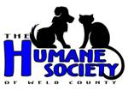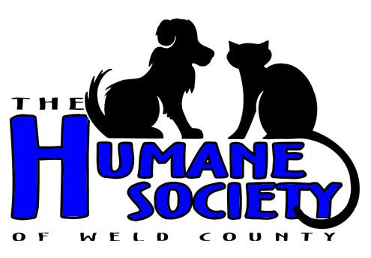

**It is highly recommended that a license tag, identification tag or microchip be on all dogs in order to reach their owners.**

**Q.** What will it cost me in court?

**A.** If convicted of a Class 2 Petty Offense, the first conviction is a $40 fine. A second conviction is an $80 fine, and a third conviction is a $300 fine and/or no more than 90 days in jail. A penalty assessment summons may be issued, with a first offense fee of $35; second offense fee of $100; third offense fee of $200; fourth offense fee of 250; and five or more offenses within 36 months will result in a mandatory court appearance.

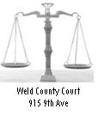

*When your dog leaves your property and visits the neighbors, the dog is considered running at large and you are in violation of county ordinance 14-4-20(b)*.

Is There A Limit On Dogs?

 Weld County has zoning ordinances that reflect the number of animal units allowed in particular zoned area of the county. Zone A agriculture may have up to 4 dogs on 1 acre, and no more than 8 dogs on 10 acres or more. More than that requires a special use permit for kenneling practices. These cases will be referred to the Planning & Zoning Services Department.

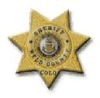

Complete copies of ordinances are available through Weld County’s web site: www.co.weld.co.us

**ANIMAL CONTROL**

**PHONE:**

**970-356-4015**

**Ext. 2849**

Weld County Sheriff’s Office

Animal Control Unit

1950 “O” Street

Greeley, CO 80631

Phone: 970-356-4015 ext. 2849

Fax: 970-304-6467

[www.weldsheriff.com](http://www.weldsheriff.com)

**WELD COUNTY**

**SHERIFF’S OFFICE**

Failure-to-Control

Ordinance

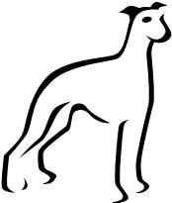

j0238963[1]



Weld County Court

915 9th Ave

Greeley, CO 80631